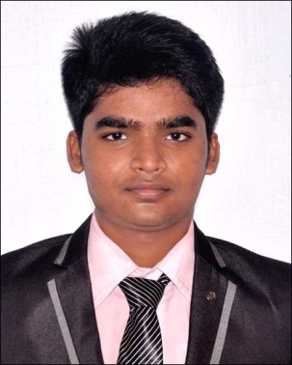

**CURRICULM VITAE**

**Susanta Kumar Rath**

**E-mail :** [**Susantarath84@gmail.com**](mailto:Susantarath84@gmail.com)

**Contact No : +91-7013403670/9853616328**

**CAREER OBJECTIVE :**

To work in a firm with a professional work driven environment where I can utilize and apply my knowledge, skills which would enable me as a fresh graduate to grow while fulfilling organizational goals.

**PROFILE :**

Well trained on **JAVA** .

**SKILL SET :**

**CORE JAVA**

* Good knowledge in OOPS concepts
* Good knowledge in classes and variables
* Good knowledge in Abstraction and Encapsulation
* Good knowledge in Java String
* Good knowledge in COLLECTION
* Good knowledge in Interfaces and Abstract class
* Good knowledge in Overloading and Overriding
* Good knowledge in Exceptions

**ADV JAVA**

* Good knowledge to develop JDBC Application
* Good knowledge in Jdbc Statement Object
* Good knowledge in Servlet Life Cycle
* Good knowledge in Java Bean
* Good knowledge in JSP Life Cycle

**SQL**

* Good knowledge on writing query **DDL,DML,TCL**
* Good Knowledge on **OPERATORS,CONSTRAINTS**

**JAVA PLATFORM**

* Good Knowledge on**:** Java 8, IDE: Eclipse (Oxygen)

**DESIGN PATTERN**

* Basic knowledge on Singleton Design Pattern
* Basic knowledge on Factory Method Pattern

**TOOLS**

* Maven

**SERVER**

* Tomcat
* Web Logic

**PROJECT :**

**FEE REPORT**

A fee report software where admin can add/view/delete accountant and accountant can add/view/edit/delete student, check due fee and logout.

**ROLES AND RESPONSIBILITIES**

* Involved in identifying scenarios
* Wrote test cases and reviewed test case

**ACADEMIC DETAILS :**

|  |  |  |  |
| --- | --- | --- | --- |
| **DEGREE** | **BOARD/UNIVERSITY** | **YEAR** | **AGGREGATE** |
| B.Tech | Biju Patnaik University of  Technology | 2012-16 | 7.3/10 |
| Intermediate | CHSE  Rourkela govt collage | 2012 | 53% |
| High School | HSE  Chinmaya Vidyalaya school | 2010 | 76% |

**DECLARATION :**

I hereby declare that the above information is correct to the best of my knowledge and belief.

Susanta Kumar Rath